Kean University



**Vehicular Data Analysis: Independent Graduate Study**

**Mobile Navigation Apps User Interface Proposal**

**By: Vaibhav Patel**

**Faculty Advisor Dr. Daehan Kwak**

**Table of Contents**

1. Abstract……………………………………………………………………………..…………………………………3
2. Introduction……………………………………………………………………….…………………………………3
3. Comparative Analysis of Navigation Apps……………………………………………………………..3
4. Current User Interfaces……………………………………………………………………………...………..5
5. Proposed User Interface……………………………………………………………………………...…….10
6. Questionnaire……………………………………………………………..….....................................11
7. Results …………………………………………………………..………………………………………………….15
8. Conclusion…………………………………………………………………………...……………………………18
9. References……….………………………………………………………………………………………………..19

**ABSTRACT**

In today’s world, we need reliable navigation systems which lead us to our destination quickly and efficiently. In addition, the most important thing in the navigation apps is its user interface (UI). The UI features of the navigation apps must be organized in a user-friendly way as safety is vital. Those features may include steps in adding addresses, selecting between multiple routes, avoiding tolls, switching between routes during the travel. In this study, a comparison of the UI for different apps with their features such as, route switching during travel, Steps until navigation starts, traffic alerts, and toll alerts are analyzed. Currently, the main deciding factor to decide on route are based on ETA or distance. We propose a new UI to supplement ETA by showing the range of the ETA on routes (i.e. variation). A user study was conducted where 25 participants completed a questionnaire. The purpose of this questionnaire was to gain demographic information about the users; see their navigation app preferences; and to see if the proposed UI using the ETA range was useful.

**INTRODUCTION**

* Millions of people use mobile navigation apps for real time directions. Mobile navigation apps are a convenient tool for traveling and searching locations.
* Most smart phones have automatic inbuilt navigations applications making mobile apps readily available.
* In this paper, I address the need for adding a range component to ETA, to provide a more precise ETA because travel time is dynamic because of a range of factors, including changes in demand, traffic operations, weather and accidents (van Lint et al., 2008).

**COMPARATIVE ANALYSIS OF NAVIGATION APPS**

To gain insight on multiple navigation apps, I conducted a comparative analysis of 6 mobile navigation apps.

|  |  |  |  |  |  |  |
| --- | --- | --- | --- | --- | --- | --- |
|  | Apple Maps | Bing Maps | Google Maps | Here Maps | MapQuest | Waze |
| Company | Apple | Microsoft | Google | Audi, BMW, Daimler | Verizon | Google |
| Crash Indication | **×** | **×** | **✓** | **×** | **✓** | **✓** |
| Previous Destinations | **✓** | **✓** | **✓** | **✓** | **✓** | **✓** |
| Max# of Routes | 3 | 3 | 3 | 3 | 3 | 3 |
| Police Indication | **×** | **×** | **×** | **×** | **×** | **✓** |
| Speedometer | **×** | **×** | **×** | **✓** | **✓** | **✓** |
| Multiple Way Points | **✓** | **×** | **✓** | **×** | **✓** | **✓** |
| Drive Later Times | **×** | **×** | **✓** | **×** | **×** | **✓** |
| Offline Map | **×** | **✓** | **✓** | **✓** | **×** | **×** |
| Parking | **✓** | **×** | **✓** | **×** | **✓** | **✓** |
| Clicks to start navigation | 4 | 4 | 3 | 5 | 4 | 3 |
| Autofill Destination | **✓** | **✓** | **✓** | **✓** | **✓** | **✓** |
| Location Sharing | **✓** | **×** | **✓** | **✓** | **✓** | **✓** |
| Voice Navigation | **×** | **×** | **✓** | **×** | **×** | **✓** |
| Mobile Version | **✓** | **×** | **✓** | **✓** | **✓** | **✓** |
| Web Version | **×** | **✓** | **✓** | **✓** | **✓** | **✓** |
| Ridesharing | **×** | **×** | **✓** | **✓** | **×** | **×** |
| Access to Music Library | **×** | **×** | **✓** | **×** | **×** | **×** |
| Save Destinations | **✓** | **×** | **✓** | **×** | **×** | **✓** |

**CURRENT USER INTERFACES**

Apple’s interface has a previous destination, multiple way points, saved parking, location sharing, traffic reports, non-driving navigation and explore neighborhood features making it very user-friendly.

Apple Maps Interface

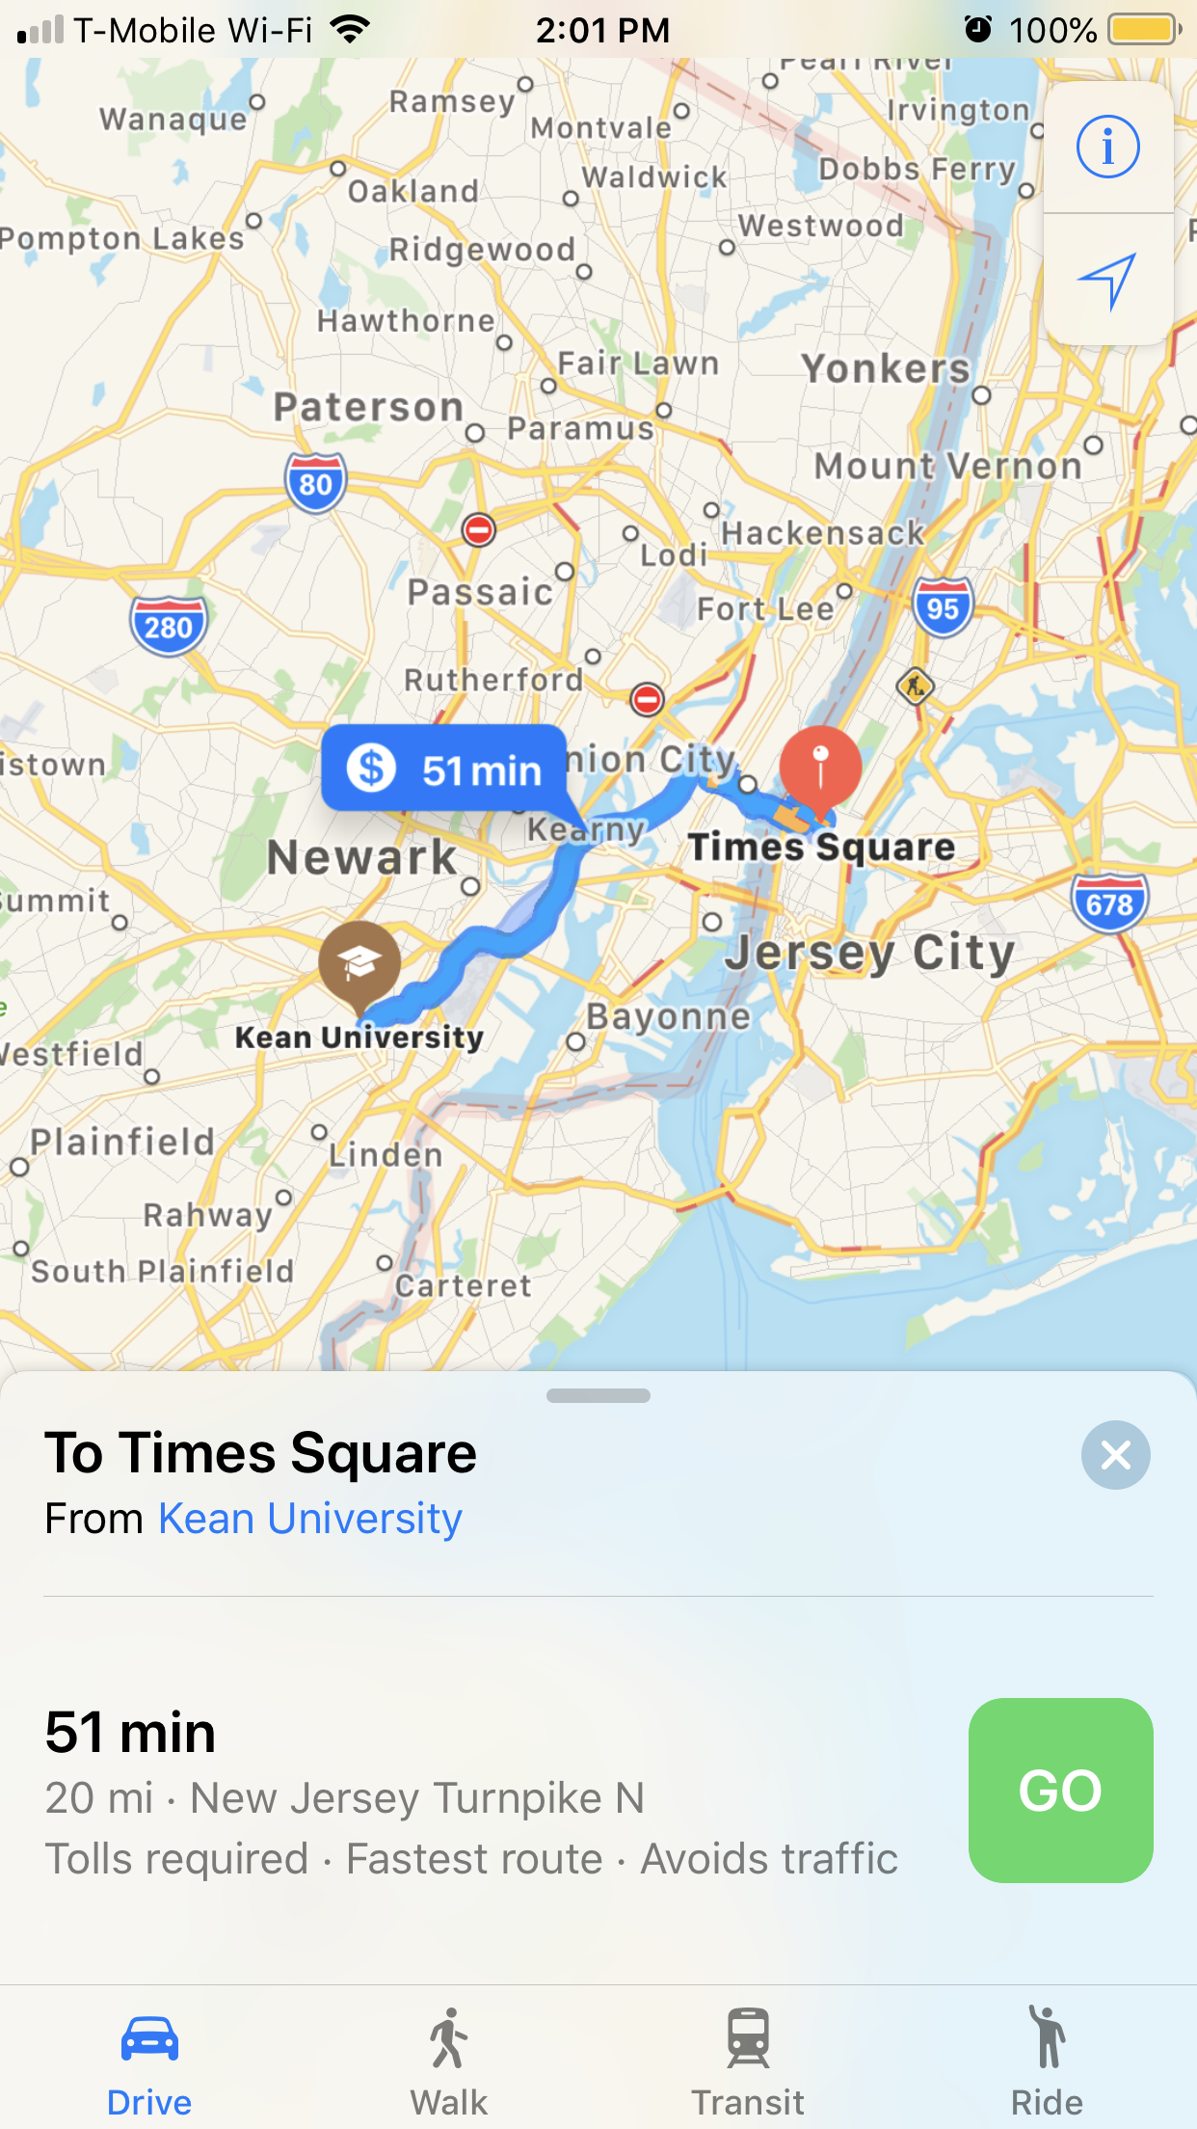

Google’s interface is the most user-friendly and most popular among the users with almost all the existing features in the navigation applications including previous destination, multiple way points, saved parking, location sharing, traffic reports, non-driving navigation, explore neighborhood, voice navigation, ridesharing, access to music library features making it very user-friendly.

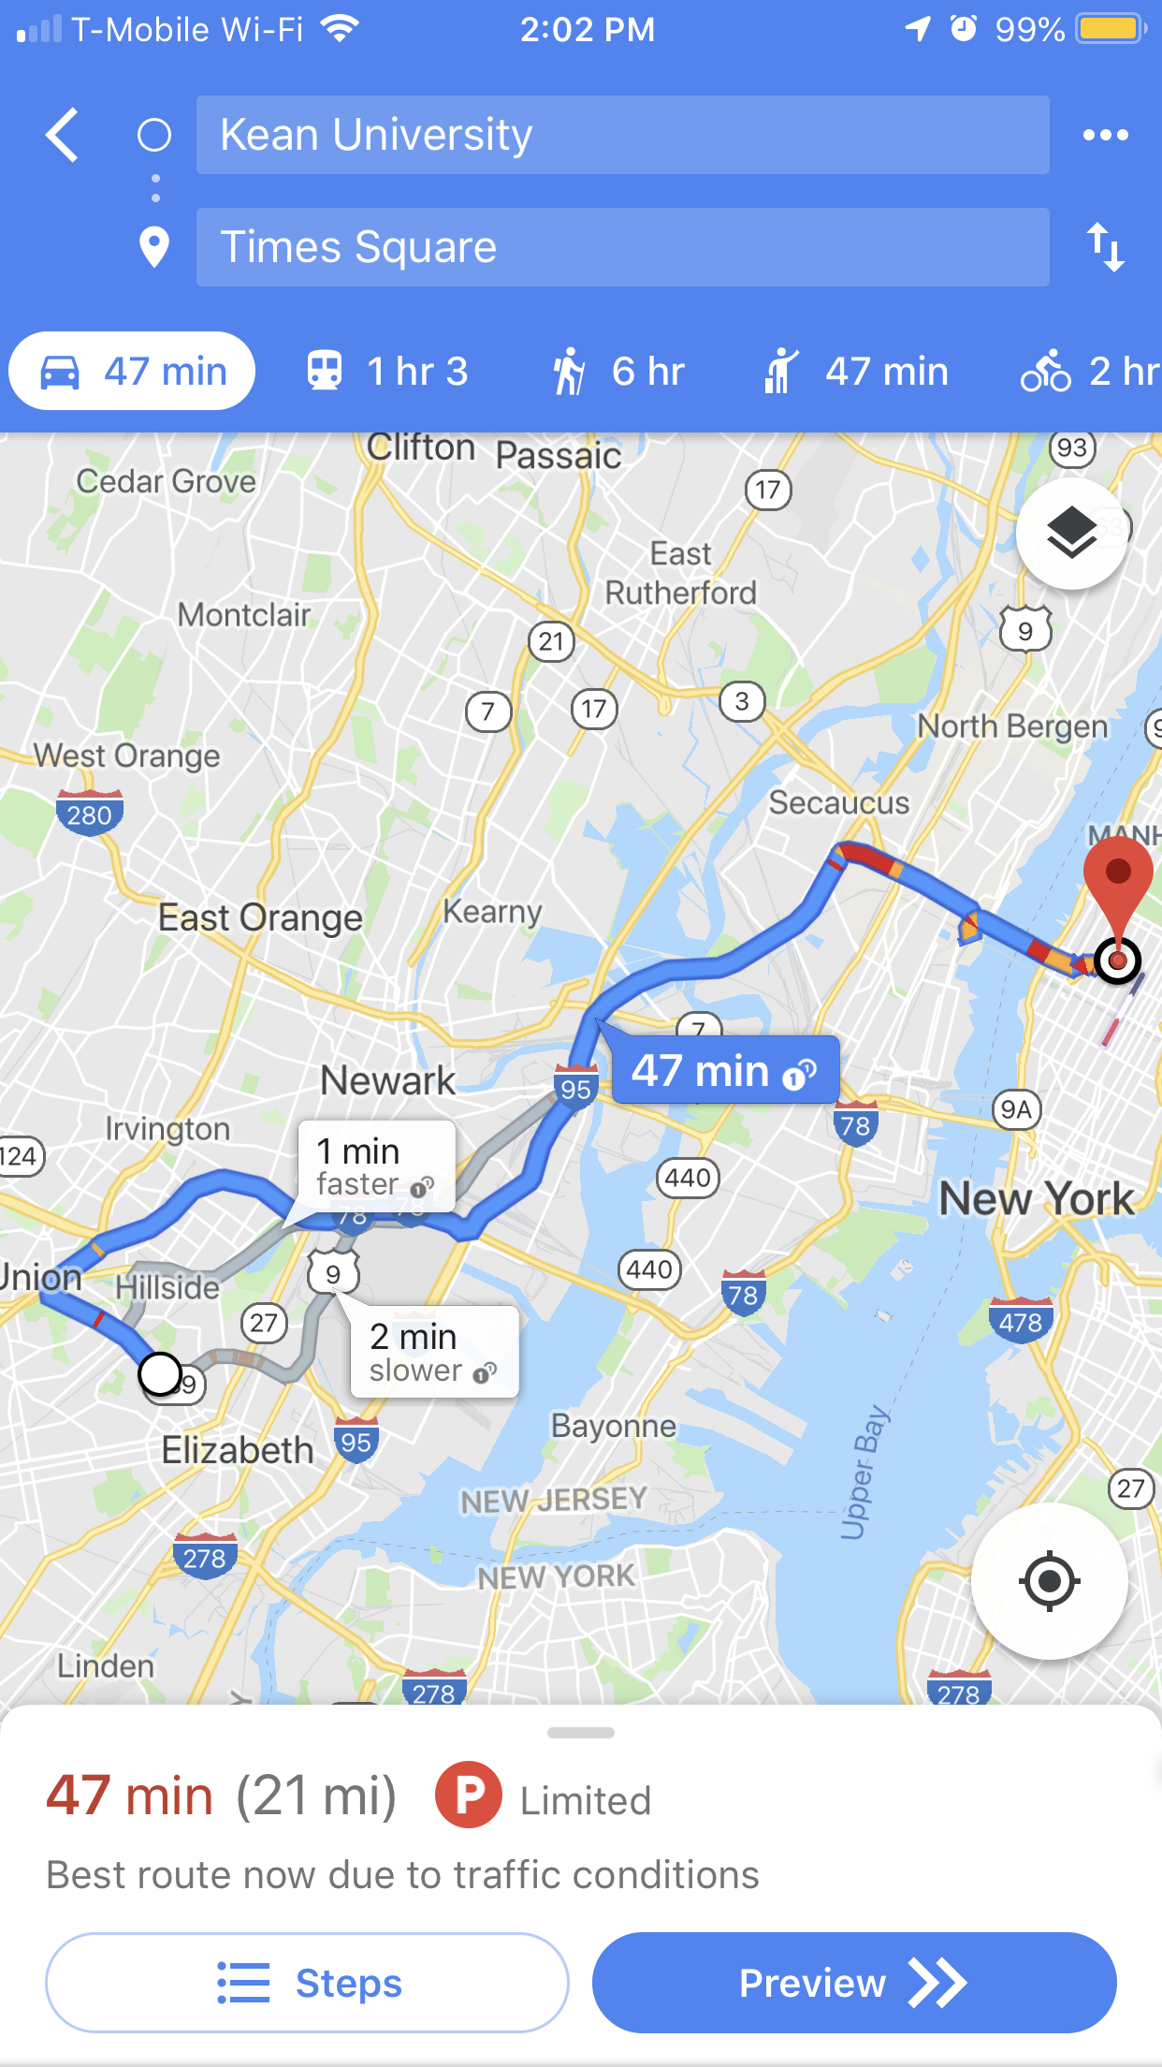

Here maps are popular in the Audi, BMW, and Daimler systems with comparatively less features than the latest mobile navigation applications. They contain all the necessary features to navigate from one point to another.

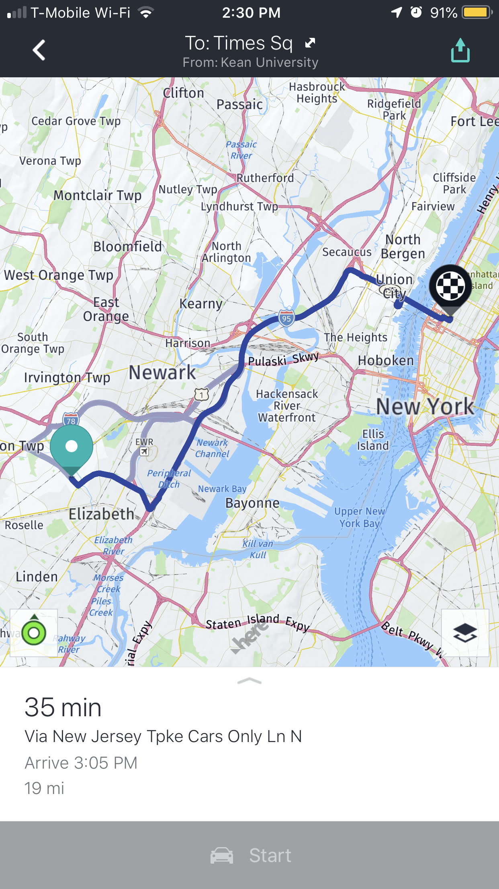

MapQuest, a Verizon owned navigagtion application has features like crash indicators, previous destination,saved parking, traffic reports, and current weather.

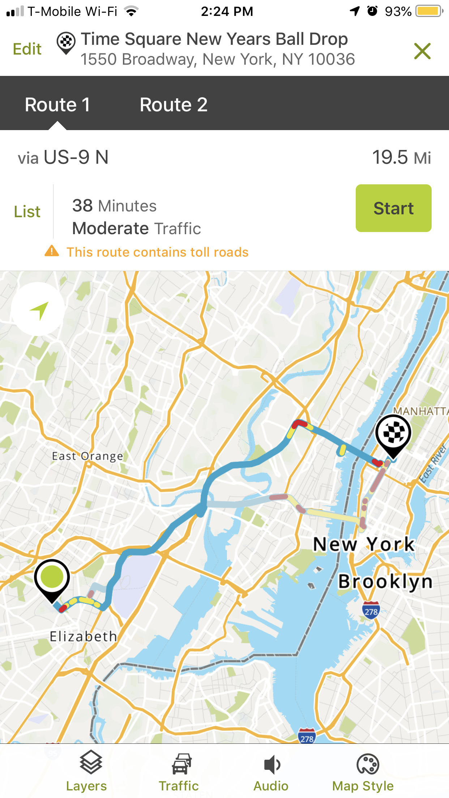

Waze is one the most popular navigation app after Google, with almost all the latest features and even more. Waze is famous for its unique features for reporting traffic, police, accident, stopped vehicles on the app and share with the users using the app on the same route making it very popular in a short period of time.

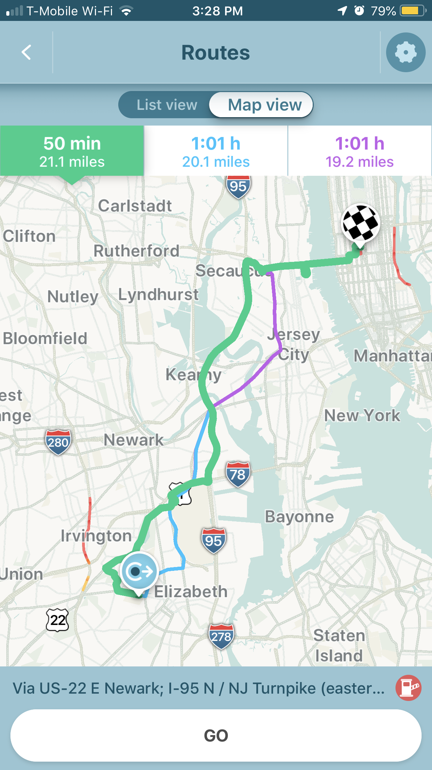

**PROPOSED USER INTERFACE**

To implement a UI that incorporates both ETA and Range, I created a wireframe.



* In the proposed user interface, the ETA and range among of all the routes is shown, making is more convenient for user to select best route.

**QUESTIONNAIRE**









**RESULTS**

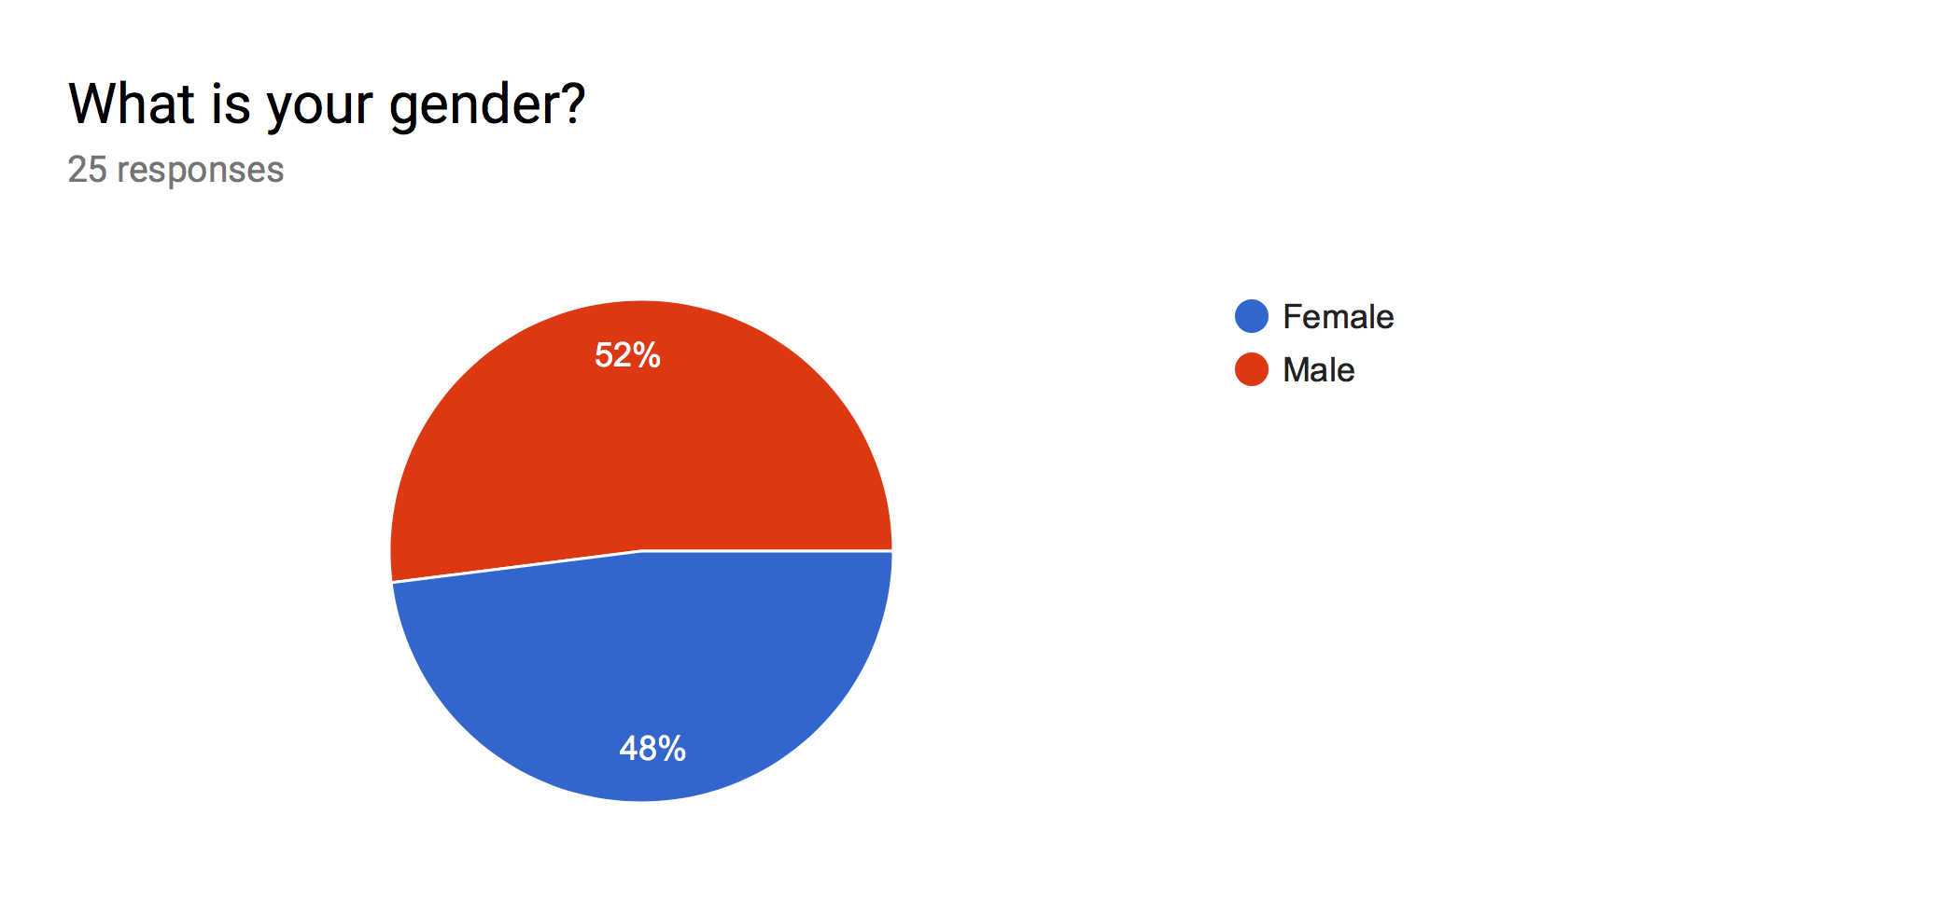

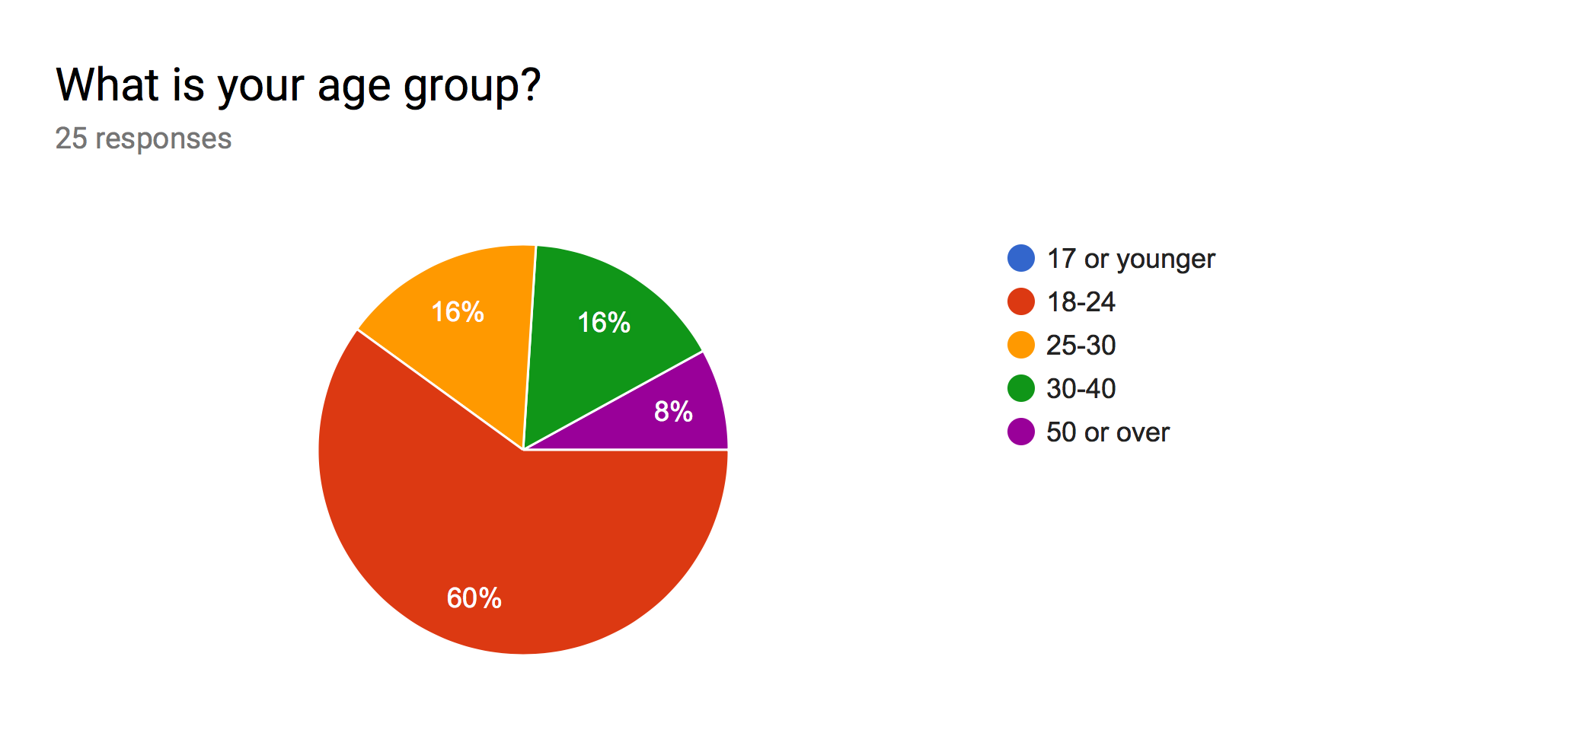

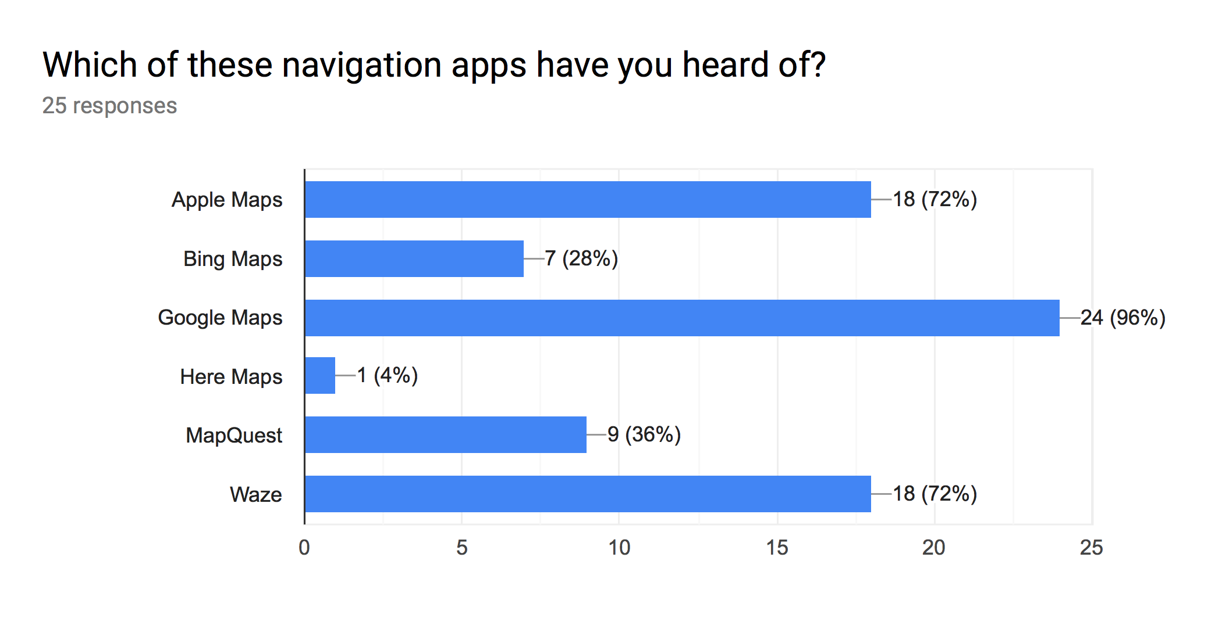

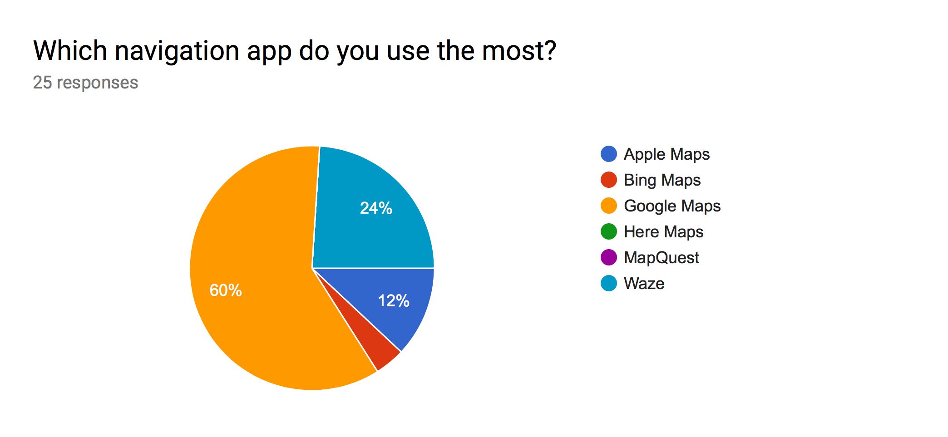

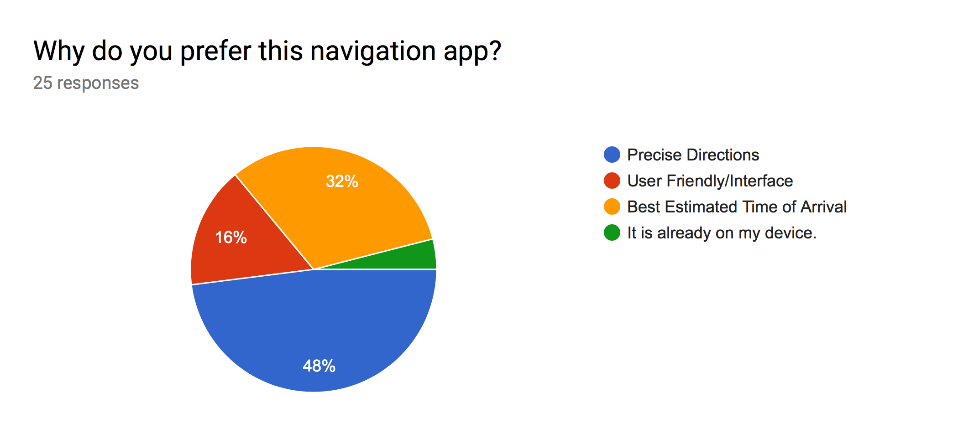

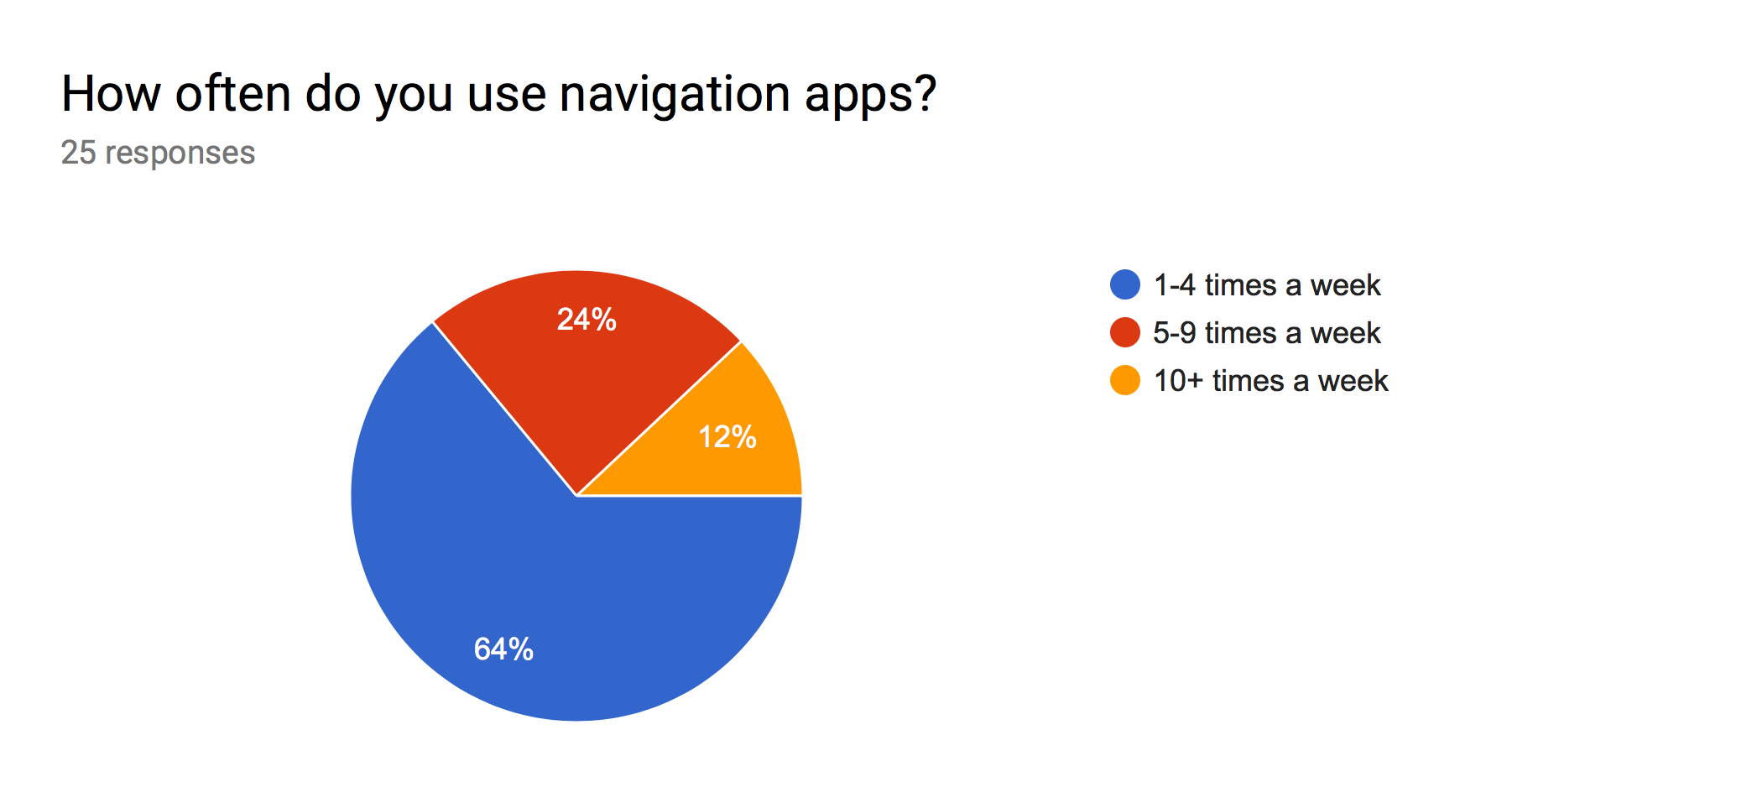

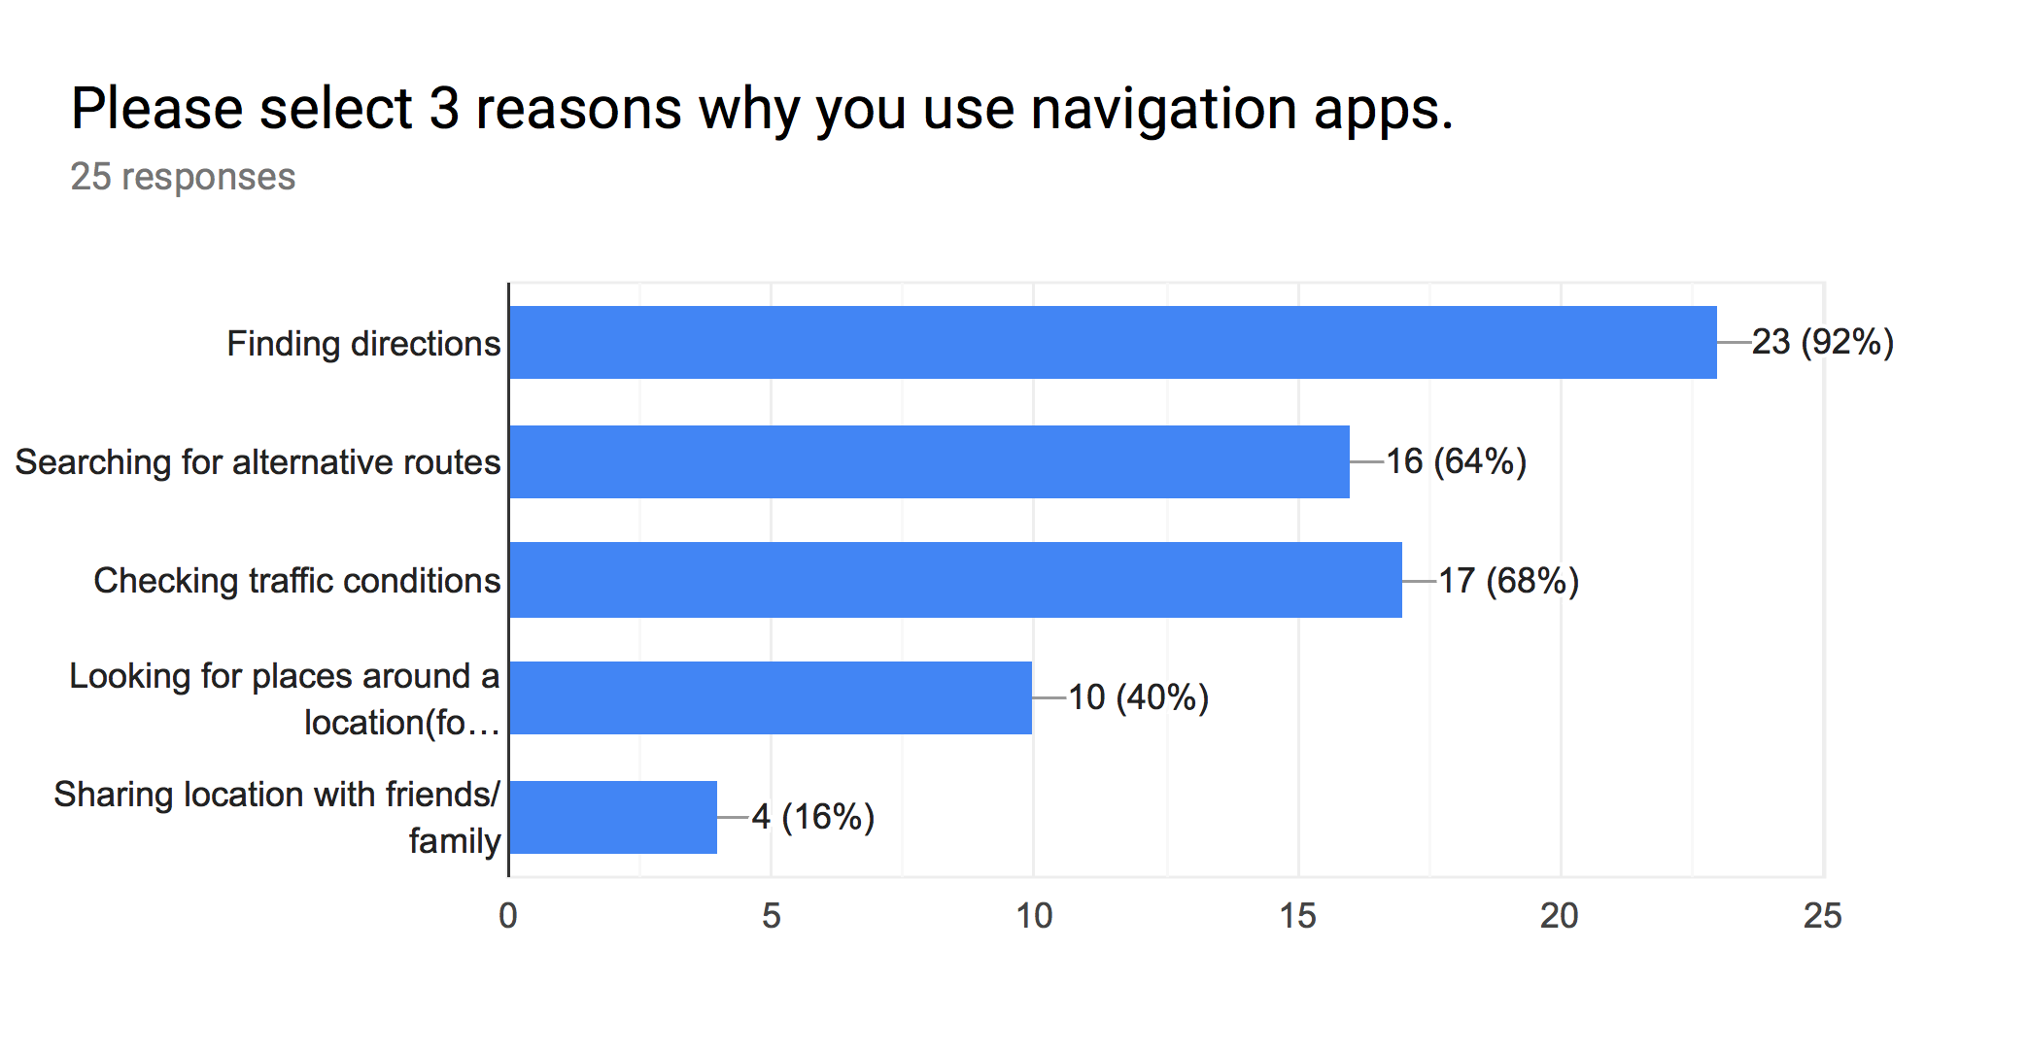

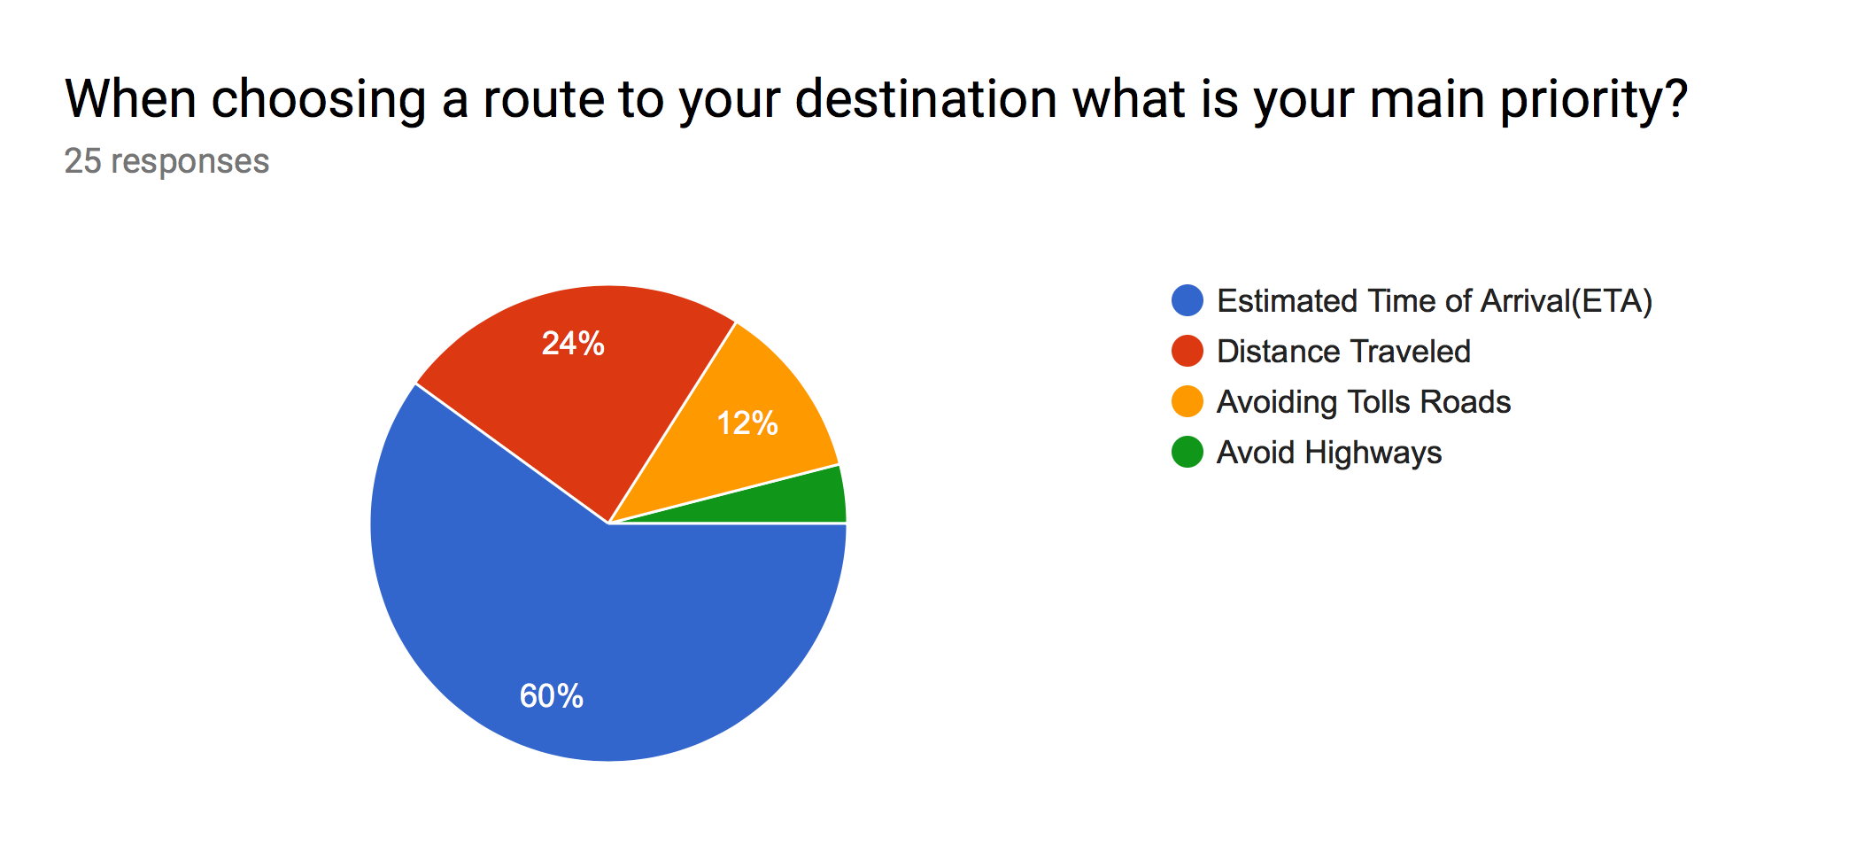

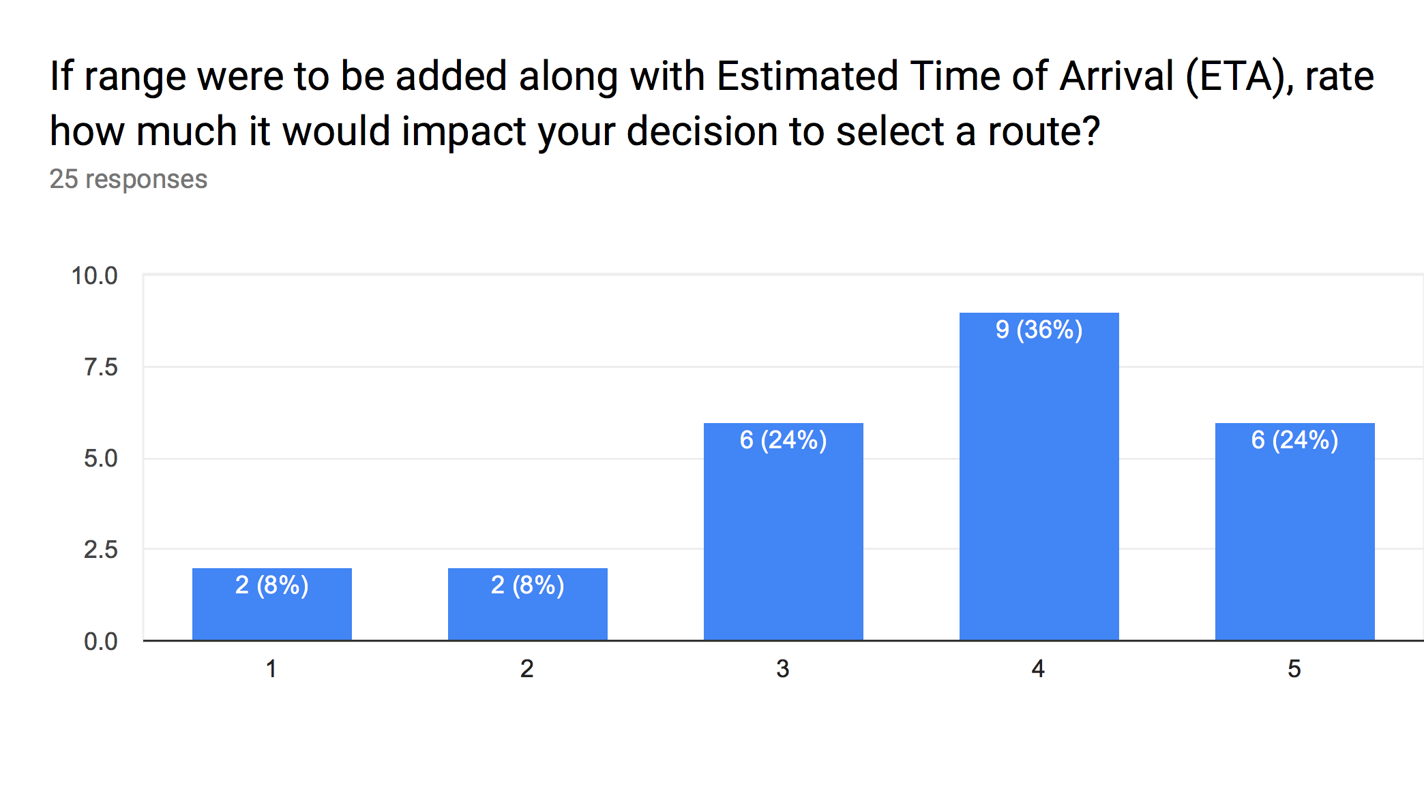

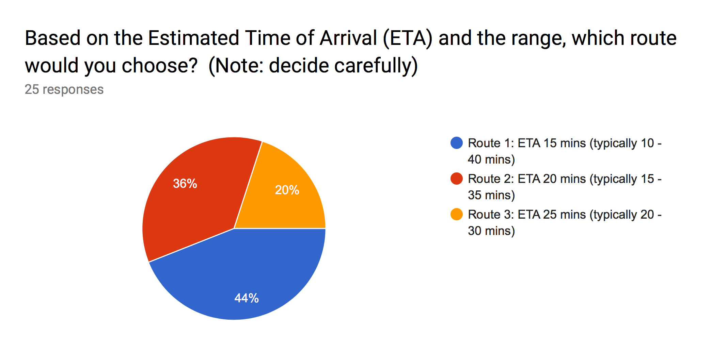

**CONCLUSION**

In this paper, I have presented a proposal to implement a UI for navigation apps to include ETA and a precise Range of times it could take to get to a destination based on real time traffic data. The study resulted in 25 participants completing a questionnaire. The questionnaire revealed that 24% of the participants chose the option 5; on a scale 1(no impact) to 5(much impact) based on the question “If range were to be added along with ETA, rate how much it would impact your decision to select a route?”. 36% of participants chose option 4; 24% of participants chose option 3; 8% chose both option 2 and 1 respectfully. This question illustrates that majority of users in this study would like to see a range added to ETA.

The question “Based on ETA and range which route would you?”, revealed that 44% of participants chose Route 1; which interprets to a faster ETA but larger range meaning it may take longer sometimes. Route 2 was chosen by 36% of participants; which interprets to a moderate ETA and range time. Route 3 was chosen by 20% of participants; which interprets to a slower ETA but normally accurate with respect to ETA and range.

**REFERENCES**

[1] Van Lint et al., “Online learning solutions for freeway travel time prediction” 2008

[2] S. Kim, J.Chung “Exploration on origin destination based travel time variability: insights from Seoul metropolitan area”(2018)